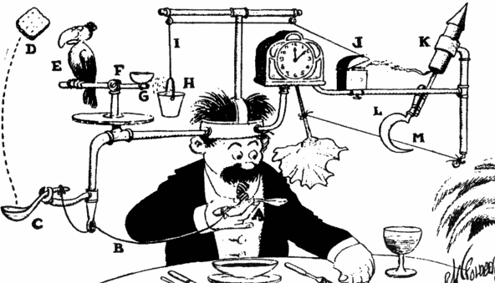

Rube Goldberg: Simply Complicated Machines
Combining Science and Visual Art to Create Unique Machines

Grade Level: 9-12
Time Estimate: Four 60 minute sessions (over 4 days)

WY Science Content and Performance Standards:

Current WY Science Content and Performance Standards:
- SC11.1.13 Energy and Matter: Demonstrate an understanding of types of energy, energy transfer and transformations, and the relationship between mass and energy.
- SC11.2.2 Students use inquiry to conduct scientific investigations.
  - Pose problems and identify questions and concepts to design and conduct an investigation.
  - Collect, organize, analyze and appropriately represent data.
  - Give priority to evidence in drawing conclusions and making connections to scientific concepts.
  - Clearly and accurately communicate the result of the investigation.
- SC11.2.4 Students investigate the relationships between science and technology and the role of technological design in meeting human needs.
- SC11.3.2 Students examine how scientific information is used to make decisions.
  - Interdisciplinary connections of the sciences and connections to other subject areas and career opportunities.
  - The role of science in solving personal, local, national, and global problems.
Proposed 2016 WY Science Content and Performance Standards:

- HS-PS3-3. Design, build, and refine a device that works within given constraints to convert one form of energy into another form of energy.

WY Fine and Performing Arts Content and Performance Standards:

Visual Art:

- FPA 11.1.A.3: Students plan and create artistic works based on use of design elements and principles
- FPA 11.1.A.4: Students collaborate with in creative artistic processes

Materials/Tools: paper, pencils, journals, various recyclable materials (aluminum foil, plastic containers, cardboard, toilet paper rolls, cereal boxes, string etc.), other miscellaneous items (dominoes, funnels, marbles, golf balls, toy cars, rubber bands, etc.) | Vocabulary: simple machine, compound machine, design, specification, two-dimensional, three-dimensional  Note: Vocabulary should be displayed on word wall.

Objective: Students will combine their knowledge of simple machines and design to create a compound machine to accomplish a simple task.

Essential Questions:
- How can simple machines work together to form a compound machine that completes a task?
- How can a two-dimensional cartoon/sketch help to plan and organize the construction of a three-dimensional simple or compound machine?

Procedure:

Introduction (Day 1; 15-20 minutes): Begin by reviewing simple and compound machines. What is a simple machine? A simple machine makes work easier for people; any of the basic mechanical devices for applying a force, such as an inclined plane, wedge, or lever. We also know that engineers can build compound machines, combining a number of simple machines to accomplish a task (example: bicycle, scissors).

Rube Goldberg was an American cartoonist, sculptor, author, engineer, and inventor. He was most famous for drawing cartoons of contraptions that accomplish a simple task in a fantastically complicated way.

Potential Examples:
https://www.youtube.com/watch?v=GOMIBdM6N7Q&feature=youtu.be
https://www.youtube.com/watch?v=qybUFnY7Y8w&feature=youtu.be
https://www.youtube.com/watch?v=cv5WLLYo-fk&feature=youtu.be -- ART

After watching videos, ask students what simple machines they noticed in the videos. What types of simple tasks did each Rube Goldberg machine accomplish? Students should record their observations in their journal. When they finish their journal, they may turn to a partner and compare observations in a brief discussion.

Planning/Exploring (45 minutes):
- In groups of 2-4, students will brainstorm ideas for a simple task they want to accomplish through a complicated process of several simple machines working. Remind groups that every member of their group should contribute to the discussion.
- Once students have selected their simple task, they will begin planning how they will accomplish this task using a series of simple machines (A minimum of 3 simple machines is required.)
- In the style of Rube Goldberg, students will draw a cartoon diagram of their machine, paying attention to the design elements of their machine and the ways in which their simple machines interact together to cause a chain reaction of events. (See example below and other examples in background information. It may be helpful to have some of these examples displayed around the classroom.)
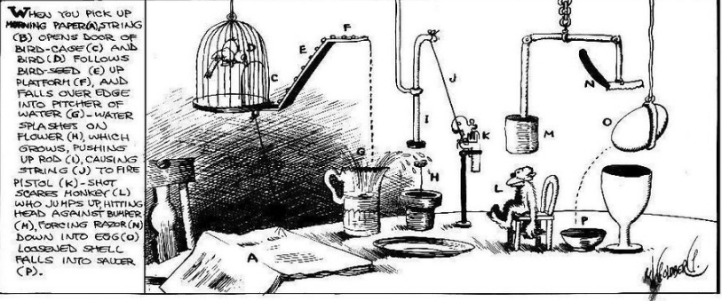
- After completing their sketches, students should create a list of materials they will need for their machines, as well as materials that they plan to bring from home to contribute.
- After teams have finished their initial plans, they will show their plans and lists to the teacher for approval and make any necessary revisions.

Create (Day 2; 60 minutes):
- Students will review their drawing plans and strategize how best to approach building their compound machine (They will build the simple machines first and then join them together to accomplish their task.)
- Students will gather materials and begin building their simple machines, making sure that all group members are participating in the construction process. Groups should be encouraged to reference their drawings throughout this process and stay as close to their original designs as possible.

Feedback/Testing (Day 3; 30 minutes):
- Once groups have finished building their designs, the groups will have the opportunity to pair up with another group to test their machines. While one group is testing out their machine, the other group will provide feedback/suggestions for improvement.
Revise/Improve (30 minutes):
- After receiving and giving feedback, groups will have time to revise and make improvements to their machines. If their machine did not need any revisions, students are encouraged to refine their designs, making sure their machine follows their original design.

Reflect (Day 4; 20 minutes):
- In their journals, individuals should write a brief description of the process and design, detailing any issues that the group encountered along the way. This description should include a list of materials used, the different simple machines that make up their compound machine, and the task that the machine completes. Then, students should write a reflection on the feedback they received from other groups during their testing phase and what improvements they made. The reflection should also include how close the actual machine models the original drawing and plans of the group.

Present (40 minutes):
- Groups will present their Rube Goldberg machines to the class, explaining their initial drawings, any improvements or revisions they made, and their reflections on the process.

Evaluation/Assessment:

Formative:

- Students will be observed throughout the project with the intention that each student will actively participate collaboratively and individually in discussion, drawing, exploratory, and creative processes.
- After Rube Goldberg machines have been revised and refined, students will have the opportunity to present their final products, self-reflect, and provide feedback/critiques during presentations.

Differentiation/Modifications:
- If a student is having difficulty using the materials, alternative materials or assistance may be provided.
- If project is taking longer than expected, the process/complexity can be simplified. (Example: Limit the number of simple machines to a maximum of 3.)

Variations/Extensions:
- A more in-depth study of Rube Goldberg’s cartoons and work could be added, depending on the time, setting, and grade level. See background information for ideas.
- A deeper examination of the satire of Rube Goldberg's work and an analysis of the usefulness of machines in society and whether or not their machine is useful or functions more as a work of art. (Inclusion of these art standards: FPA 11.1.A.6: Students select, prepare and exhibit their artwork and explain their choice FPA 11.3.A.2: Students describe the function and explore the meaning of specific art objects within varied cultures, eras, and environments
- A more in-depth explanation and exploration of simple and compound machines could be added. Mechanical advantage could also be discussed and added into this lesson.
- A more formal, written reflection of the hypothesis, process, revisions, and final product can be required.
- A more defined rubric/list of requirements for the machine can be added to make the design process more challenging.
- If time/materials allow, students could create their own videos, showcasing their machines and explaining their process and resulting product.

Background/Research/Additional Resources:
For inspiration on Rube Goldberg machines, please explore the following videos.
- https://www.teachingchannel.org/videos/rube-goldberg-contraptions
- https://www.teachengineering.org/lessons/view/cub_simp_machines_lesson05
- https://www.rubegoldberg.com/

