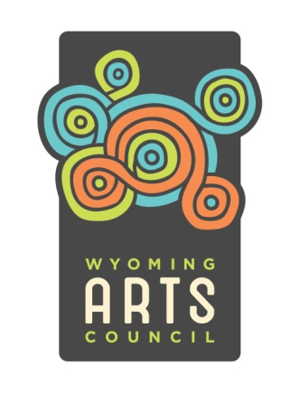
APPLY FOR THE WAC ARTIST ROSTER!

The Wyoming Arts Council Artist Roster is a juried list of Wyoming artists interested in working with Wyoming schools and organizations. Artists of all kinds are welcome to apply. The process is competitive, based on the artistic merit and quality of programming. Roster artists are selected through a rigorous panel process that rates applicants on artistic criteria such as artistic professionalism, presentation, expression and subject matter.

How often are applications accepted? Once a year

When is the application available? October 1st

What is the deadline? December 1st

Who is eligible to apply? Wyoming residents who live in Wyoming as their
permanent residence 10 months of the year, and are
18 years of age or older

What type of artists can apply? Literary, performing and visual artists Folk artists may apply in any of these categories

How do I apply? Via CaFE (Call for Entry) from the Western States Arts Federation

How do I get to CaFE? http://www.callforentry.org

Is there a fee to register for CaFE? No – it is free!

When should I register in CaFE? Register anytime! - No need to wait until October 1st

How should I submit my work samples? Upload these to your CaFE Profile anytime

Problems working in CaFE? Contact CaFE HELP on line

What is the Roster time frame? July 1, 2014 - June 30, 2015

How long will I be on the Roster? Approved artists may be carried forward up to five years

Why apply to be on the Roster? *Roster artists receive a WAC “stamp of approval”
*Approved artists can be hired via Artists Across
WY grants and other WAC grant programs
*Roster artists receive state wide exposure

Who can apply for AAW grants? 501c3 nonprofits and government agencies

Where can Roster info be found? A directory is printed annually, and information is available at http://www.wyomingartscouncil.org.

CALL THE WAC AT (307) 777-7743 FOR MORE INFORMATION!

