Wyoming Arts Council Mentoring Project Grant Overview
Everyone practices folk and traditional skills that are passed from one person to another and are shaped out of common experiences. We sing hymns at church, cook a special meal for a birthday, give a bride something blue, carve a pumpkin at Halloween, fiddle a waltz at a dance, recite a poem at the grange hall, or tell a joke at a local cafe. No matter where we are, if we look closely, we find folk arts happening.
Mentoring Project Grants are designed to support the transmission of Wyoming’s finest Traditional and Folk Skills through the natural process of in-person, hands-on instruction. A master artist selects a worthy apprentice to mentor over time in order to advance the skills of the student from proficient to excellent. All art forms (music, dance, craft, etc.) are encouraged. For a list of previous projects, see page 4.

Project Period & Length
The mentorship must take place January through October 2016. Projects must be no shorter than six months.

Award Amount & Payment Schedule
Up to four projects will be selected for funding at $3,000 each ($2,300 for the master artist’s honorarium and $700 for supplies and travel). All project costs over $3,000 must be paid by the award recipients. The award will be paid in two installments: the first payment of $2,100 in January and the second payment of $900 in June. The award recipients are responsible for any taxes due on the awarded funds.

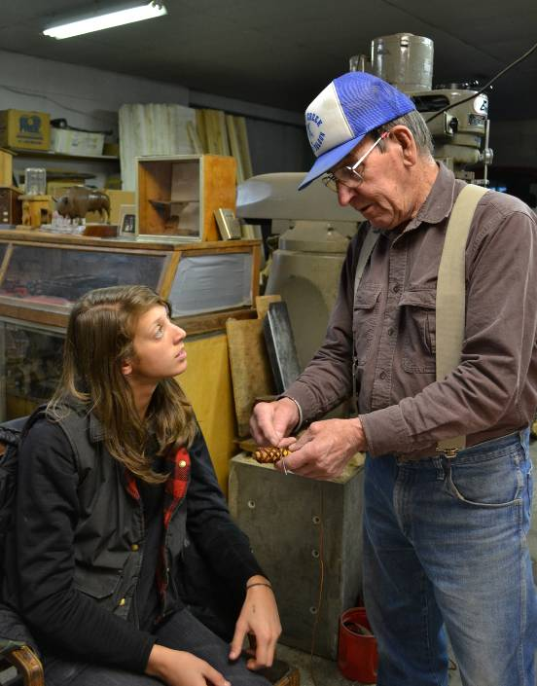
Eligible Proposals
- Applicants must share a common cultural group and the art form must reflect the aesthetics of the shared group. In-family mentorships are allowed.
- Master and apprentice must apply together.
- Artists may participate in only one Mentoring Project each year.
- Apprentices must be Wyoming residents for at least two years prior to application.
- Apprentices should not be younger than 18 years of age.
- Apprentices must be at a proficient level of skill at the time of the application.
- Apprentices must demonstrate a serious long-term commitment to continuing the art form.
Ineligible Proposals
- The work of contemporary studio artists or re-creations of historic repertoires or antiques.
- Academic research or formal study toward an academic or professional degree.
- Projects less than six months.
- Workshops or conferences.
Mentoring Project Grant Overview contnued
Deadline
All materials must be postmarked by or on September 1, 2015 and should be mailed or delivered to:
Wyoming Arts Council Mentoring Project
2301 Central Avenue
Cheyenne, WY 82002
Late applications will not be accepted. Applications may be delivered in person to the Wyoming Arts Council office no later than 5 p.m. on the due date. Applications submitted by facsimile (FAX) or email will not be accepted.

Questions?
Contact Anne F. Hatch, Folklorist and Access Specialist at 307-777-7721 or anne.hatch@wyo.gov
Application Evaluation and Selection
Applications are reviewed and evaluated by a panel of cultural specialists, folklorists, artists and WAC board members using the following criteria:
- Quality of the work as demonstrated by the support materials of both the master and the apprentice.
- How the art form and artists fit within the definition of folk and traditional art.
Priority may be given to projects that involve endangered traditions and/or art forms.
- Commitment of the apprentice to continuing the traditional skills learned.
- Feasibility of the proposed work plan.
The full WAC board reviews the panel recommendations and makes the final selection of funded projects. Applicants are notified in December of the WAC Board’s decisions.
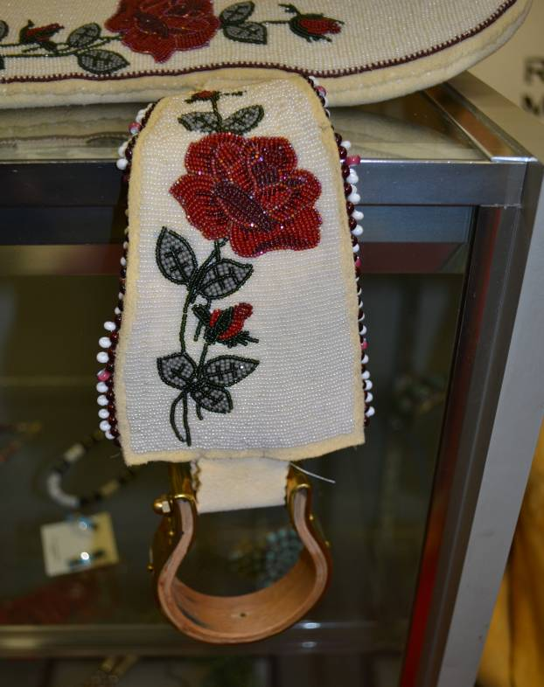

Selected Projects
If a project receives funding, the Folklorist or a representative will visit during the grant period to document the mentorship through photographs, video and/or sound recordings. Materials generated during the site visit will be housed in the Wyoming Folklife Collection and made available for research and educational purposes.
Mentoring Project Grant Application written requirements
Artist Information and Project Description
All applicants must submit the following three written sections along with the cover sheet, budget sheet, support materials, and letters of recommendation.

Part 1: Master Artist Information (To be completed by the Master Artist)
On a separate page (no more than two), answer the following questions. Put your name and the art form at the top of each page, and indicate by number which question you are answering.
- Describe the traditional craft, performance or skill you wish to teach. Include what community/group supports your work and what your relationship is to that community/group.
- What is the role or importance of this art to you and your community, ethnic group or region?
- Where, how, when and from whom did you learn this tradition?
- Where do you usually work on your art, or where do you perform? What do you do with your work?
- Why did you choose this apprentice? Describe your previous teaching experience.

Part 2: Apprentice Information (To be completed by the Apprentice)
On a separate page (no more than two), answer the following questions. Put your name and the art form at the top of each page, and indicate by number which question you are answering.
- Why do you want to learn this skill? What is your relationship with the community/group that supports this art form?
- Where, how, when and from whom did you learn this tradition or a related skill?
- Where do you usually work on your art, or where do you perform?
- Why do you want to work with this master artist? Describe how you know this person and in what capacity, if any, you have worked with her or him prior to this project.
- What are your plans for working with this art form after the mentorship?

Part 3: Project Description (To be completed by the Master and Apprentice together)
On a separate page (no more than two), answer the following questions. Put your name and the art form at the top of each page, and indicate by number which question you are answering.
- Describe exactly what will be taught during this project. What specific skills will the apprentice learn? What do you expect to accomplish during the apprenticeship (list of songs, dances, items to be made)?
- Where and when will you work together? Describe your schedule for meeting including number per week or month, length, and the total number. The project must occur between January and October 2016 and be six months or longer.
a completed application
Submit the following: 1) cover sheet, 2) budget, 3) examples of work, 4) letters of support, 5) Master and Apprentice artist information, and 6) project description to WAC Mentoring Project, 2301 Central Ave, Cheyenne, WY 82002. All materials are due to the WAC office postmarked by or delivered on September 1, 2015 by 5 p.m.
Mentoring Project Grant PREVIOUS PROJECTS
The Wyoming Arts Council introduced the Folk & Traditional Arts Mentoring program in 2005 as part of its on-going effort to increase support and recognition of Wyoming’s rich cultural arts and traditions. Funds originally came from a National Endowment for the Arts Infrastructure grant provided to the WAC Arts Access Program.

Folk Art Skill | Master | Apprentice
 | 2006
Loom weaving | Gerald Curcio | Judith Harvey
Performance knives | Ed Fowler | Tena Osborne
Cowboy music | Kevin McNiven | Terrell and TeAnna McNiven
Old-time fiddling | Kelly Wells | Coletta Maier
 | 2007
War shields | W. Chippewa | Patrick Thayer
Men’s beaded vests | Cleo Goggles | Linda Goggles
Tatting & crochet | Mary Maynard | Isobel Nichols
Rawhide braiding | Jack Mease | Mike Alley
Basket weaving & furniture caning | Sally O’Connor | Maria Foster
Shoshone saddle trappings | Reba Jo Teran | Georgietta Teran-Acebo
 | 2008
Round dance songs | Sandra Iron Cloud | Norman and Samuel Iron Cloud
Tatting | Mary Maynard | Molly Moyer
Rawhide braiding | Jack Mease | Michael Stewart
N. Arapaho regalia | Annie Sage | Veronica Miller
N. Arapaho crafts | Annin Soldier Wolf | Hista and Echo Soldier Wolf
Old-time fiddling | Kelly Wells | Tally Wells
 | 2009
Saddle building | Don Butler | Tom Stevie
Native American willow back rest | William Chippewa | Patrick Thayer
Tatting | Mary Maynard | Molly Moyer
Sheep to shawl | Avis Richardson | Group apprentices
N. Arapaho beaded buckskin dress | Annin Soldier Wolf | Cathi Soldier Wolf
 | 2010
Folk Art Skill | Master | Apprentice
E. Shoshone Cradleboard | Charlotte Alley | Lynelle Shakespeare
E. Shoshone drums | W. Bonatsie | Quinlin Hernandez
Saddle tree making | G. K. Fraker | Steve Dabbs
Parfleche | Gloria Goggles | J. R. T. C. Lodge
Rawhide braiding | Jack Mease | Brenda Hovendick
Folk Art Skill | Master | Apprentice
 | 2011
Eastern Shoshone woman’s saddle | Charlotte Alley | Amanda Alley
Jewish and Israeli dance | Bea Montross | Mary Weinstein
Horsehair hitching | Richard Gould | Leane Linnell
Arapaho and Lakota women’s singing | Sandra Iron Cloud | Rebecca Iron Cloud
Rawhide and leather braiding. | Jack Mease | Mila Ready
 | 2012
Warrior shirt | Elizabeth Brown | Danielle Brown
Beaded leggings | Marcus Dewey | Veronica Miller
Rams horn bow | Tom Lucas | Richard Singer
N. Arapaho beaded buckskin dress | Annie Sage | Janelle Denny
E Shoshone Woman’s traditional saddle | Joanne Seesequasis | Larry McAdams
 | 2013
Saddle building | Keith Duncan | Kurt Olson
Rug braiding | Norma Sturges | Ellen Sue Blakey
Rawhide making and braiding | Nate Walk | Caleb French
Old-time Fiddling | Kelly Wells | Kayla Palmer
 | 2014
Intertribal songs | P. Iron Cloud | N. & S.Iron Cloud
Arapaho Hand Drum | D. Lone Bear | Tyson Lone Bear
Rawhide Braiding | Jack Mease | Sally Hovendick
Rug braiding | Norma Sturges | Ellen Sue Blakey
 | 2015
Leatherwork | Niki DeLancey | McKenzi Digby
Teepee bags/panniers | Marcus Dewey | Charles Dewey
Leatherwork | Von Ringler | Alex Whistler

Mentoring Project Grant Application Cover Sheet
Note: Before completing the application, read the overview. Make a copy of your completed application before submitting, for your records. If more than one apprentice is applying, provide a Cover Sheet and Apprentice Information for each.

Master Artist’s name
Mailing address
PO Box or Street/City/State/Zip County
Daytime phone Evening or message phone
E-mail address Website
Date of birth Place of birth
Places raised
* * * * *
Grant Amount requested: $ 3,000

Project Period: Start Date___________________ End Date

Project Title: TRADITIONAL ART FORM
Brief Project Description

* * * * *
Apprentice Artist’s name
Mailing address
PO Box or Street/City/State/Zip County
Daytime phone Evening or message phone
E-mail Address Website
Date of birth Place of birth
* * * * *
Agreement: I am willing to participate in the plans as outlined in this application. I hereby certify that the Apprentice in a legal resident of Wyoming since Jan. 1, 2014, and that the application information is true and complete to the best of my knowledge. I agree to allow WAC to duplicate any materials submitted with the application for purposes of the selection process. The award recipient will be responsible for any taxes due on received funds. A WAC representative may visit to document the project for the Wyoming Folklife Collection. Products made during the grant are the property of the maker.

Master Artist’s Signature Date

Apprentice Artist’s Signature Date
Mentoring Project Grant Application Budget Sheet & Support Materials
Master Artist’s Name
Apprentice Artist’s Name
MATERIALS AND TRAVEL:
List the costs for supplies/tools and number of trips (report where to and from and the mileage – current state mileage reimbursement rate is 57.5 cents per mile). Amounts up to $700 will be paid by the grant. Additional expenses must be paid by the applicants.
Description Cost
Travel: ____________________________________ ____________________________________
____________________________________ ____________________________________
____________________________________ ____________________________________
____________________________________ ____________________________________
Supplies: ____________________________________ ____________________________________
____________________________________ ____________________________________
____________________________________ ____________________________________
____________________________________ ____________________________________

Total Materials & Travel ($700 from the WAC) ______________________________
MASTER ARTIST FEE: $2,300
TOTAL REQUEST: $3,000
Please be aware that recipients of funds are responsible for any taxes due.

SUPPORT MATERIALS
Examples of the master artist’s and apprentice’s work are necessary for the panel to evaluate the application. No application will be considered without work samples. Support materials can include photographs, artifacts, CDs, DVDs, and/or other items.
Master Artist Work Samples (required) Apprentice(s) Work Samples (required)
check boxes on each type support submitted check boxes on each type support submitted
and list the quantity or items beside and list the quantity or items beside
[ ] photos, quantity ____________ [ ] photos, quantity ____________
[ ] audiotapes, quantity ____________ [ ] audiotapes, quantity ____________
[ ] CDs, quantity ____________ [ ] CDs, quantity ____________
[ ] DVDs quantity ___________ [ ] DVDs quantity ____________
[ ] other ____________________ [ ] other ____________________

Letters of support: One for each artist is required. No more than three per artist accepted. Letters can come from an individual or a community, tribe, church or a cultural organization that is aware of your ability and excellence in the art form.

