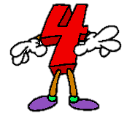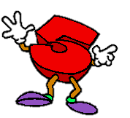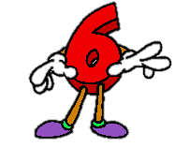

Math Moves!
Combining Dance and Traditional Notation to Compare Numbers

Grade Level: 2 (Note: Standards can be modified so the lesson can be used in the K-1 setting.)
Time Estimate: 45-60 minutes

WY Math Content and Performance Standards:

- 2.NBT.4 Compare two three-digit numbers based on meanings of the hundreds, tens, and ones digit, using >, =, and < symbols to record the results of comparisons.

WY Fine and Performing Arts Content and Performance Standards:

Dance:
- FPA4.1.D.1 Students explore isolated and coordinated dance movements with body awareness
- FPA4.1.D.3 Students demonstrate the elements of dance, including shape, level, pathway, spatial awareness, and energy/movement quality
- FPA4.4.D.1 Students explore a concept or idea from another discipline through movement

Materials/Tools: hand drum and/or creative dance music, symbol posters, number cards, individual white boards and markers or notebooks and pencils, copies of the exit slip | Vocabulary: equal to, greater than, less than, compare, demonstrate  Note: Vocabulary should be displayed on word wall.

Objective: Students will demonstrate their ability to compare two and three-digit numbers using < = > symbols through dance and traditional notation.

Essential Questions:
- How can I compare numbers using the < = > symbols?
- How can I use movement to demonstrate my understanding of comparing numbers using the < = > symbols?

Procedure:

Behavioral Expectations: (3 minutes)
We have two rules for class today:

1. Always keep space around yourself. Never touch anyone else, the walls, or the steps unless I ask you to.
2. When the music or the drumming stops, you must freeze!
Let’s practice. When the music starts, dance and move around the room, but when the music stops you must freeze! Don’t move even one eyelash!

(Note: There are some videos in the background information at the end of the lesson if you would like to show a video to demonstrate appropriate classroom behavior to your students for the movement parts of the lesson.)

Mini-Lesson/Review: (10-15 minutes)
Today we are learning about three symbols that we use to compare numbers. The symbols are posted on our wall. These symbols are used to show if a number is bigger, smaller, or equal to another number. You already know one symbol. Which one is that? The equal sign! (Show or point to symbol in the classroom.) The next symbol is the greater than symbol. (Show or point to symbol in the classroom.) The greater than symbol is used when one number is bigger than another number. You always point the open side toward the bigger number. When I see the greater than symbol, I like to think of a mouth. If the symbol is a wide-open, hungry mouth, then it will want to eat as much as possible. That’s how you know to point it toward the bigger number. The other symbol is the less than symbol. (Show or point to symbol in the classroom.) This symbol is the opposite of the greater than symbol. You use this symbol when one number is smaller than another number.

Let’s practice using these symbols together as a class.

22 ___ 10 100 ___ 320 45 ___ 400 32 ___ 32

Display these numbers on a white board, Smart board, or flip chart. Randomly select students using name cards, popsicle sticks, or another whole-class participation strategy. Have students write the correct symbol in the blank and read the comparison out loud. (Example: Twenty two is less than ten.) Discuss the correct answers.

Whole Class Explore/Investigate: (10-15 minutes)
Now, let’s demonstrate our knowledge of these symbols using dance movements! When I hold up the greater than sign, move in a high level. When I hold up the equal to sign, move in a medium level, and when I hold up the less than sign, move in a low level. Demonstrate all three levels for students. If time permits, you can come up with these movements as a class. Decide on a uniform movement that represents each symbol. Try to have the movement mimic the symbol in some way to help solidify students’ understanding. See pictures below for some ideas.

HIGH (greater than) MEDIUM (equal) LOW (less than)
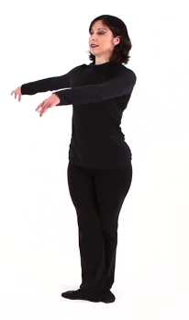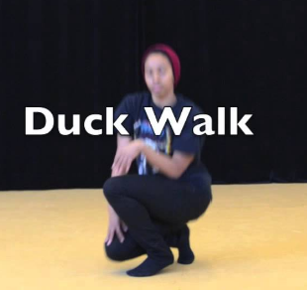

Let’s practice these moves. Hold up each symbol and allow students to practice. Try turning and jumping to get into the move. Make interesting shapes while you move. Can you move lower?

Now, let’s use our dance movements to compare numbers. When you hear the music or drum, get into the dance movement that shows the correct symbol. When the music stops, freeze in the correct movement!

250 ___ 200 51 ___ 51 120 ___ 220

Display these numbers on a white board, Smart board, or flip chart. Show two numbers at a time. Have students write the correct symbol in the blank after class gets into the dance movements. Discuss the correct answers and demonstrate the correct movements.

Partner/Small Group Investigate/Explore: (15 minutes)
Give each student a number card and a writing surface and utensil (Examples: small white board, notebook, index card). Number cards should be random and show a three-digit number. Assign partners or let students pair up. Compare your number card with your partner. Decide if your number is greater than, less than, or equal to your partner’s number. Write your numbers down with the correct symbol. Then, practice your dance movement to show your understanding through dance! Each group will share their written numbers and symbols and their dance with the class. Provide a count-down timer so students know how much time they have before they perform. What happens if you switch the order of the numbers? Does the symbol change? The teacher should try to visit each pair to answer questions and correct any confusion during this preparation time.

Perform: (10 minutes)
Now, we will perform! Allow each group to share their dance and written version with the class.

Closing/Exit Slip: (5 minutes)

Directions: Fill in the blanks with the correct symbol. < > =

350 ___ 320 127 ___ 127 510 ___ 570 120 ___ 110 432 ___ 432

When you are finished, choose one pair of numbers and compare them using the dance movement you learned in class. Demonstrate your understanding to your teacher when you turn in your exit slip.

Evaluation/Assessment:

Formative:

- Students will be observed throughout the lesson with the intention that each student will actively participate collaboratively and individually in discussion and movement explorations.
- Students will complete an exit slip to show individual understanding and allow teacher to follow up with any students that may still have some confusion.

Differentiation/Modifications:
- If the lesson is taking longer than expected, the process/movement activities can be simplified or the performance section can be removed/moved to another day.
- If a student is having difficulty performing a movement, an alternative movement may be provided or the student can hold up a poster of the symbol.

Variations/Extensions:
- After the completion of this lesson, students can complete one or all of the following tasks. (Tasks are from Illustrative Mathematics https://www.illustrativemathematics.org/) Students can complete individually or in small groups. After completing the tasks using traditional notation, students can create and choreograph their own dance to show a comparison between more than two numbers and demonstrate their understanding through movement. Note: This extension would address the following standard: FPA4.1.D.5: Students demonstrate a sequence of movements, remember them in a short phrase and identify the beginning, middle and end
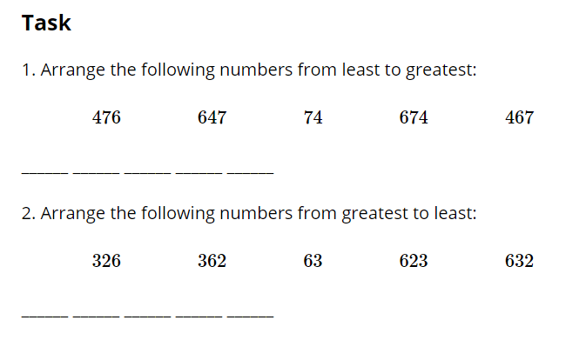
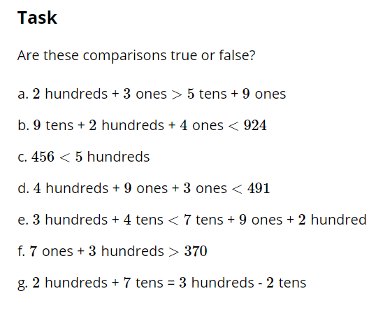
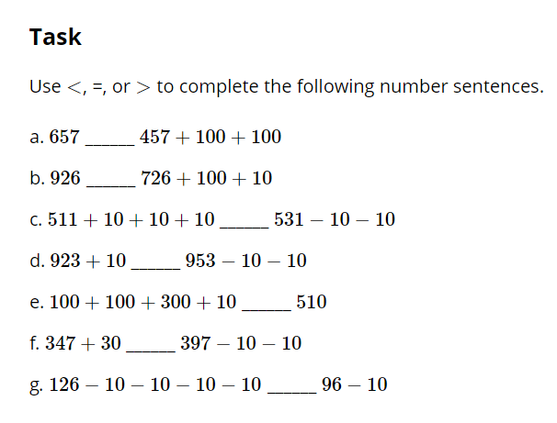

Background/Research/Additional Resources:
- For inspiration on using dance in math and other subjects, please explore the following videos. The first two videos are most closely related to this lesson and grade level.
- https://www.youtube.com/watch?v=-jwG5NaieWE
- https://www.youtube.com/watch?v=NwEE4H48ApQ
- https://www.youtube.com/watch?v=i6qB2pTSRm8 -- Tap dance with math
- https://www.youtube.com/watch?v=Ws2y-cGoWqQ -- TED talk on math & movement

Note: Original lesson plan written by Erika Cravath. Modifications made by collaboration between WDE and WAC.

